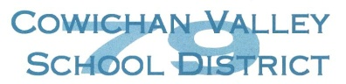
School District #79 (Cowichan Valley)
Authorization to Observe Student and/or to Share Verbal Information
About the Student as it Pertains to the Observation

I, hereby authorize
(Parent/Legal Guardian)
, to observe my child,
(name of person and agency)
, in the school setting.

(name of school)

I give permission for information to be shared regarding my child for the following purpose(s):

Please Note: A Consent for Release of Information Form must be signed for release of written information, reports, etc.

(Signature of Parent/Legal Guardian) (Date)

